# Acknowledgement

The internship opportunity I had with BCAS campus was a great chance for learning and professional development. Therefore, I consider myself as a very lucky individual as I was provided with an opportunity to be a part of it. I am also grateful for having chance to meet so many wonderful people and professionals who led me through this internship period.

I express my deepest thanks to the assessor Mr. Mohamed Ishraque, who works as an IT professional and take lectures on computer programming related subjects and others supportive subjects. He helped me taking part in useful decision & giving necessary advices and guidance and arrange all facilities for this assignment. I choose this moment to acknowledge his contribution gratefully. I acknowledge that this assignment was done with help of internet resources.

Sincerely,

S. SHALOMSHAN

Date:05.11.2021

# Introduction

The primary purpose of this assignment is to give a deep brief explanation about the Business Intelligence concept. This assignment points out some most important essential fundamentals about BI. It also focuses on BI paradigms and the other required BI tools for decision making.

All of the requirements of this assignment have been done in a perfect manner. The task one is mainly focused on the basic idea business process and the mechanisms used to support business decision making. And provide a presentation BI tool and advantaged and disadvantages.

Next, I have to task two that is explained tools and technologies associated with business intelligence functionality.

The next task is the group presentation explained about suitable example of BI, BI tools and techniques used in BI after the presentation I have do design a BI tool application interfaces based on scenario.

Last forth task impact of the business intelligence tools and technologies for effective decision-making purpose and the legal/regularity context in which they are used.

**Contents**

Acknowledgement 1

Introduction 2

Task 1 6

Task 1.1 6

What is Tableau? 6

Advantages of using Tableau 7

Disadvantages of using Tableau 7

What is QlikView? 7

Advantages of QlikView 8

Disadvantages of QlikView 8

Task 1.2 8

Difference between Structure, Semi-structured and Unstructured data 8

Structured data 9

Semi-Structured data 9

Unstructured data 9

Task 1.3 10

Presentation & Speaker Notes 10

Task 2 21

Task 2.1 21

Compare the types of support available for business decision making varying levels within an organization 21

Type of support available for business decision making 21

Decision making at different levels in the organization 22

Comparative study on different decision making at varying level 23

Task 2.2 24

Justify, with specific example, the key features of business intelligence functionality 24

Business intelligence functionality 24

Compare and contrast a range of information systems and technologies that can be used to support organization at operational tactical and strategies levels 26

Four major types of systems 27

Executive support system (ESS) 27

Management information system (MIS) 28

Decision support system (DSS) 29

Transaction support system (TPS) 30

Relationship to system to one another 31

Task 3 32

Task 3.1 32

Presentation & Speaker Notes 32

Task 3.2 47

Design a BI tool, Application or interface for NOLIMIT to support their problem solving or decision making for their business requirements. 47

Sales & Marketing Dashboards 47

Customer Dashboards 48

Financial Dashboards 49

HR Dashboards 50

Operational Dashboards 51

IT Dashboards 52

Project Dashboards 53

Mobile Dashboards 54

Task 4 55

Discuss how power bi business intelligence tools can contribute to effective decision making 55

Decision making tools use in business intelligence 56

Explore the legal issues involved in the secure exploitation of business intelligence tools 57

Cyber security management 57

Discovering BI security risk 58

Methods to protect the risk 58

Encrypting & Segmenting data insights 58

Determining access and permissions 58

Applying BI to data security 59

Conclusion 60

Reference 61

**List of Tables**

Table 1 Decision making at varying level 22

**List of Figures**

Figure 1 Slide_1 11

Figure 2 Slide_2 11

Figure 3 Slide_3 12

Figure 4 Slide_4 13

Figure 5 Slide_5 14

Figure 6 Slide_6 15

Figure 7 Slide_7 16

Figure 8 Slide_8 17

Figure 9 Slide_9 18

Figure 10 Slide_10 19

Figure 11 Slide_11 20

Figure 12 Predicative analytics 24

Figure 13 Data visualization 25

Figure 14 Four major types of systems 27

Figure 15 ESS 28

Figure 16 MIS 29

Figure 17 DIS 30

Figure 18 TPS 30

Figure 19 Relationship to system 31

Figure 20 Slide_1 32

Figure 21 Slide_2 33

Figure 22 Slide_3 34

Figure 23 Slide_4 35

Figure 24 Slide_5 36

Figure 25 Slide_6 37

Figure 26 Slide_7 38

Figure 27 Slide_8 39

Figure 28 Slide_9 40

Figure 29 Slide_10 41

Figure 30 Slide_11 42

Figure 31 Slide_12 43

Figure 32 Slide_13 44

Figure 33 Slide_14 45

Figure 34 Slide_15 46

Figure 35 Sales dashboards like this one show data on product and retail sales, plus other sales-related metrics 47

Figure 36 A customer dashboard displays data about a company's customers, as seen here in an interactive format. 48

Figure 37 Financial dashboards include various finance-related metrics -- in both desktop and mobile views in this example 49

Figure 38 HR dashboards offer a mix of workforce and employee experience data; this one shows productivity metrics 50

Figure 39 Operational dashboards contain data on business operations and processes, such as power usage by IoT devices 51

Figure 40 IT dashboards show data on technology usage and other IT metrics -- cloud computing costs in this case 52

Figure 41 A project dashboard provides real-time metrics on projects so project managers can track their status 53

Figure 42 Mobile dashboards display data in a format suitable for mobile devices, such as this one showing sales 54

# Task 1

## Task 1.1

# What is Tableau?

Tableau is one of the most popular Business Intelligence tools, which helps in analyzing the data visually. It allows us to create and distribute the interactive dashboard, which displays the trends, variations, and density of the data in the form of charts and graphs. It can easily acquire data from files, relational and big data sources, and processes it. It also provides for data blending and real time collaboration.

It holds high importance for business, academic researchers, and many government organizations, whose main focus is data collection and its analysis through visual analytics.

## Advantages of using Tableau

* Visual capabilities
* Easy creation of interactive visuals
* High performance
* Multiple data source connection
* Support to other scripting languages
* Responsive UI
* Community and forum support

## Disadvantages of using Tableau

* Lake of automatic scheduling
* No custom visual imports
* Restrictions in custom formatting
* Static and single value parameters
* Pricing
* Intensive staff training
* Integration into existing infrastructure

# What is QlikView?

QlikView is one of the leading business discover platforms available. It is built with a number of features that differentiate it from traditional BI tools on the market. It is programmed to analyze data through different colors, which are used to indicate the relationship between different types of data. It also indicates the data that are not related.

## Advantages of QlikView

* Dynamic environment
* Data interpretation and analysis
* Data sharing
* Independent handling of QlikView
* Low on maintenance
* In memory storage
* Data compression
* QIX engine
* Direct and indirect searches
* Affordable cost

## Disadvantages of QlikView

* Technical expertise
* Poor customer support
* Embedding
* Work om old function

## Task 1.2

# Difference between Structure, Semi-structured and Unstructured data

Data is a raw information or unorganized form that represents condition, ideas or objects. It is limitless and occur everywhere in the universe. In business intelligence data can be in different forms such structured, unstructured and semi structured data.

## Structured data

Structured data is data whose elements are addressable for effective analyses. It has been organized into a formatted repository that is typically a database. It concerns all data which can be stored in database SQL in a table with rows and columns. They have relational keys and can easily be mapped into pre designed fields. Today those data are most processed in the development and simplest way to manage information.

**Example:**

* **Sensor data:** Radio frequency ID tags, smart meters, medical devices, system data, management and inventory control.
* **Web log data:** application, networks, and so on operate
* **Point of sale data:** when the cashier swipes the bar code of any product that you are purchasing
* **Financial data:** company symbol and dollar value
* **Input data:** This is any place of data that a human might input into a computer such as name, age, income, non free form survey responses and so on

## Semi-Structured data

Semi-Structured data is information that dose not reside in a relational database but that has some organizational properties that make it easier to analyze. With some processes, you can store them in the relational database (it could be very hard for some kind of semi-structured data), but semi-structured exist to ease space.

**Example:**

* Email
* CSV, XML and JSON documents
* NoSQL databases
* Electronic data interchange
* RDF

## Unstructured data

Unstructured data is a data which is not organized in a predefined manner or dose not have a predefined data model, thus it is not a good fit for a mainstream relational database. So for unstructured data, there are alternative platforms for sorting and managing, it is increasingly prevent in IT systems and is used by organizations in a variety of business intelligence and analytics applications.

**Example:**

* **Text files:** spreadsheets word processing, emails, logs and presentation
* **Website:** YouTube, Instagram
* **Social Media:** data from social media platform such as Facebook, Twitter, LinkedIn
* **Communication:** Chats, Phone recordings
* **Mobile data:** Text messages, Locations
* **Business applications:** Productivity application, MS Office documents
* **Media:** Digital photos, MP3, audio and video files
* **Digital surveillance:** Surveillance video and photos

## Task 1.3

# Presentation & Speaker Notes



Figure 1 Slide_1

Hi everyone I am shalomshan I am studying at csd batch 08 so today I will conduct this presentation is business intelligence tools and other advantages, disadvantages.

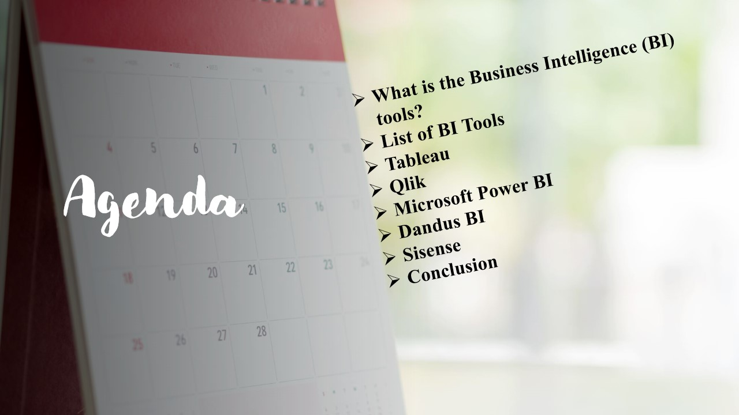

Figure 2 Slide_2

This is my content page these are content of my presentation.

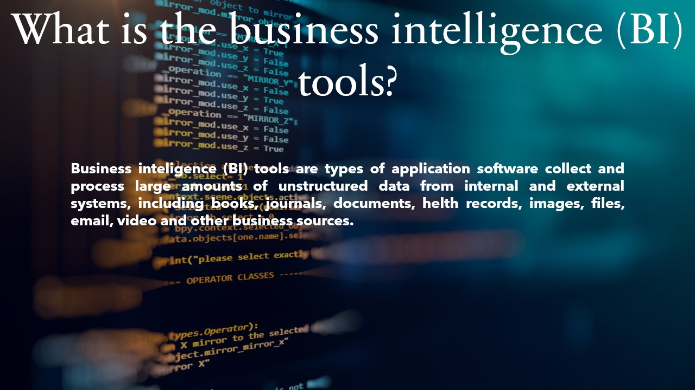

Figure 3 Slide_3

So now get started what is the business intelligence tools?

Business intelligence tools are types of application collect process large amounts of unstructured data from internal and external system, including books, journals documents, health records, images, files, email, video and other business source

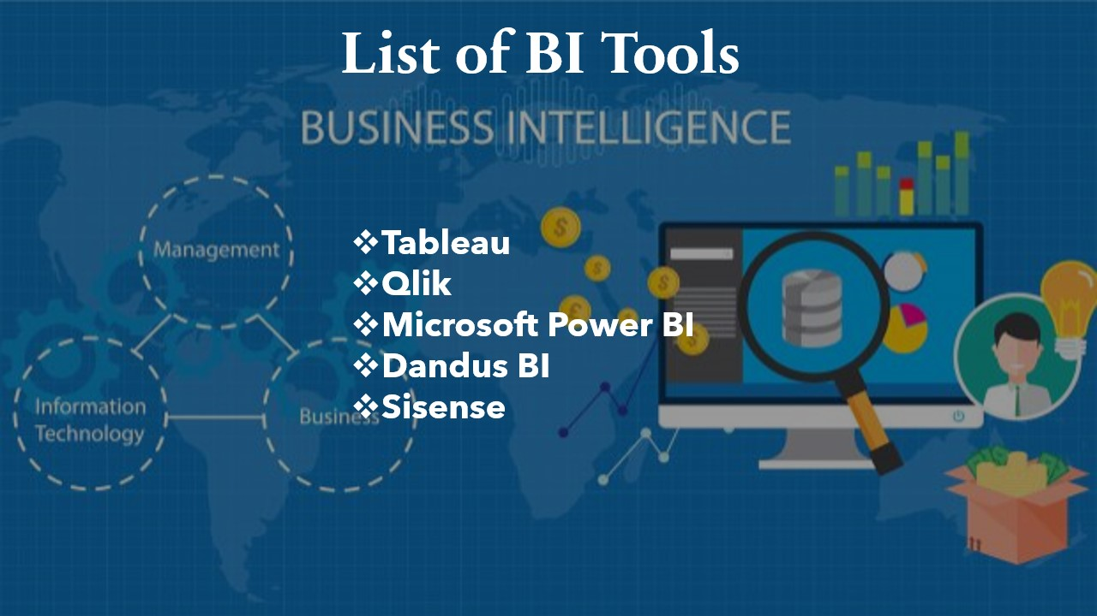

Figure 4 Slide_4

List of BI tools

Tableau, qlik, Microsoft power BI, dandus BI, sisense and these bi tools I will explained deeply.

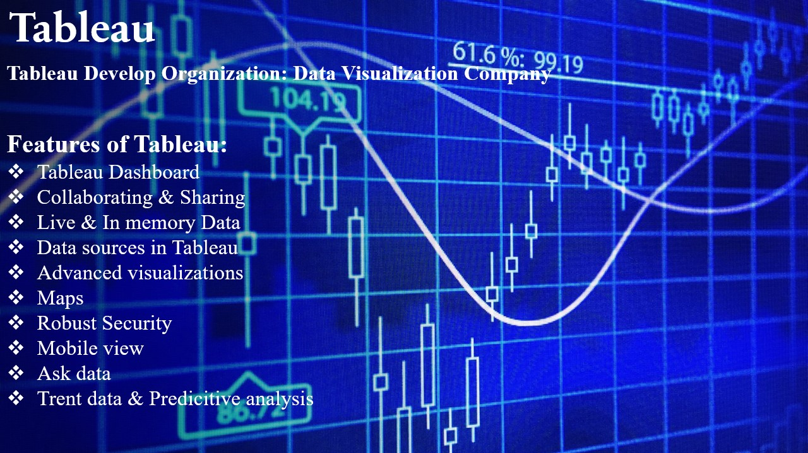

Figure 5 Slide_5

**What is tableau?** is a powerful and fastest growing data visualization tool used in the Business Intelligence Industry. It helps in simplifying raw data in a very easily understandable format. Tableau helps create the data that can be understood by professionals at any level in an organization. It also allows non-technical users to create customized dashboards

Tableau Develop Organization: Data Visualization Company

Features of Tableau:

* Tableau Dashboard
* Collaborating & Sharing
* Live & In memory Data
* Data sources in Tableau
* Advanced visualizations
* Maps
* Robust Security
* Mobile view
* Ask data
* Trent data & Predicative analysis

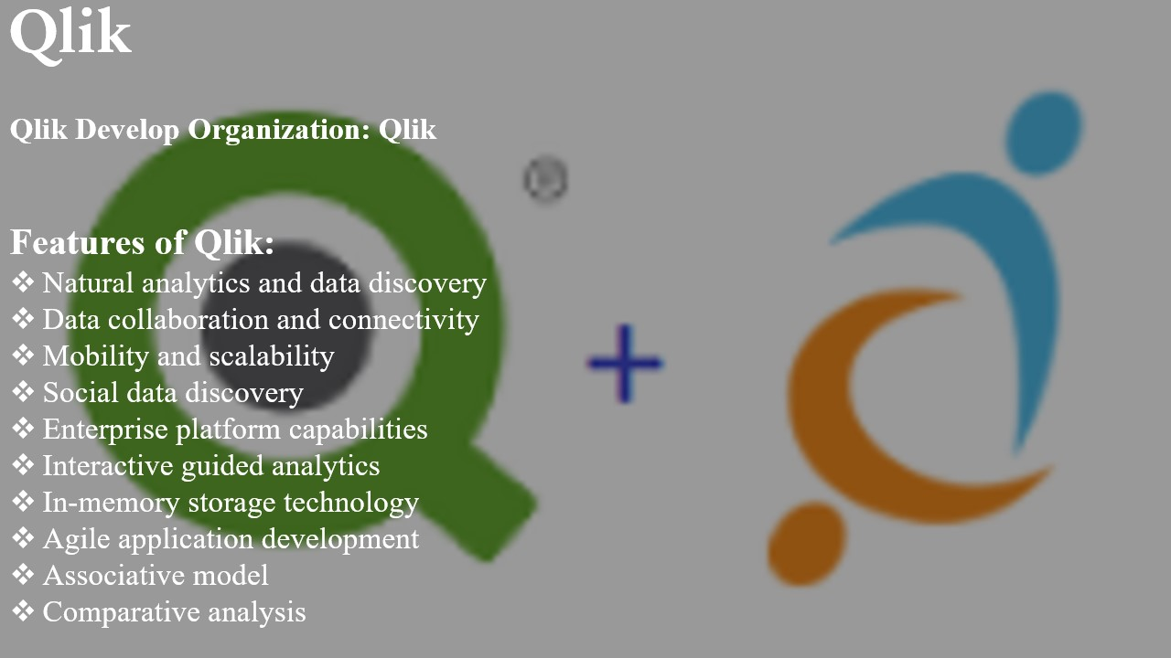

Figure 6 Slide_6

What is qlik?

**QlikView** is a business intelligence tool for data integration, conversational analytics, and converting raw data into a knowledge base. QlikView offers features for [ad hoc queries](https://www.guru99.com/all-about-ad-hoc-query.html) and facilitates quick decision-making based on easily accessible information.

Qlik Develop Organization: Qlik

Features of Qlik:

* Natural analytics and data discovery
* Data collaboration and connectivity
* Mobility and scalability
* Social data discovery
* Enterprise platform capabilities
* Interactive guided analytics
* In-memory storage technology
* Agile application development
* Associative model
* Comparative analysis

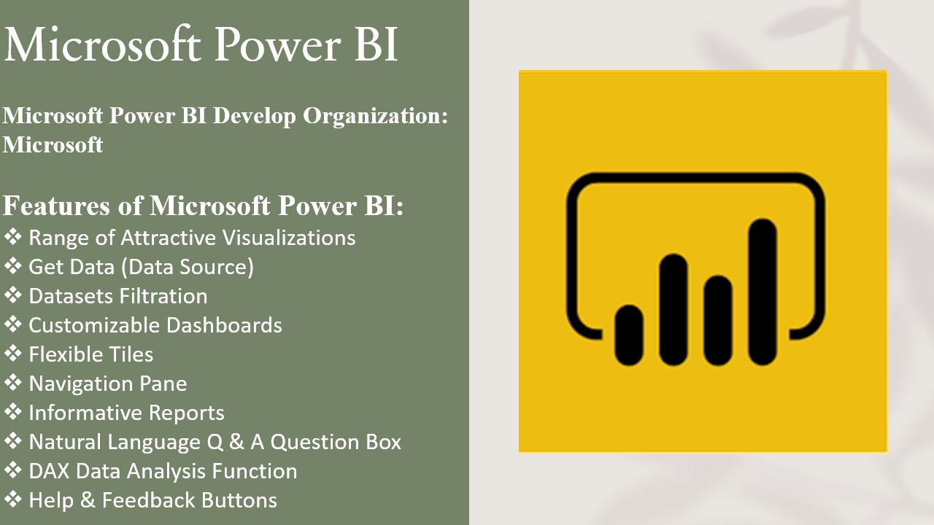

Figure 7 Slide_7

What is power bi?

Business intelligence is a technology-driven method which helps you to analyze data and to provide actionable information which helps corporate executives, business managers, and other users to make informed business decisions.

Microsoft Power BI Develop Organization: Microsoft

Features of Microsoft Power BI:

* Range of Attractive Visualizations
* Get Data (Data Source)
* Datasets Filtration
* Customizable Dashboards
* Flexible Tiles
* Navigation Pane
* Informative Reports
* Natural Language Q & A Question Box
* DAX Data Analysis Function
* Help & Feedback Buttons

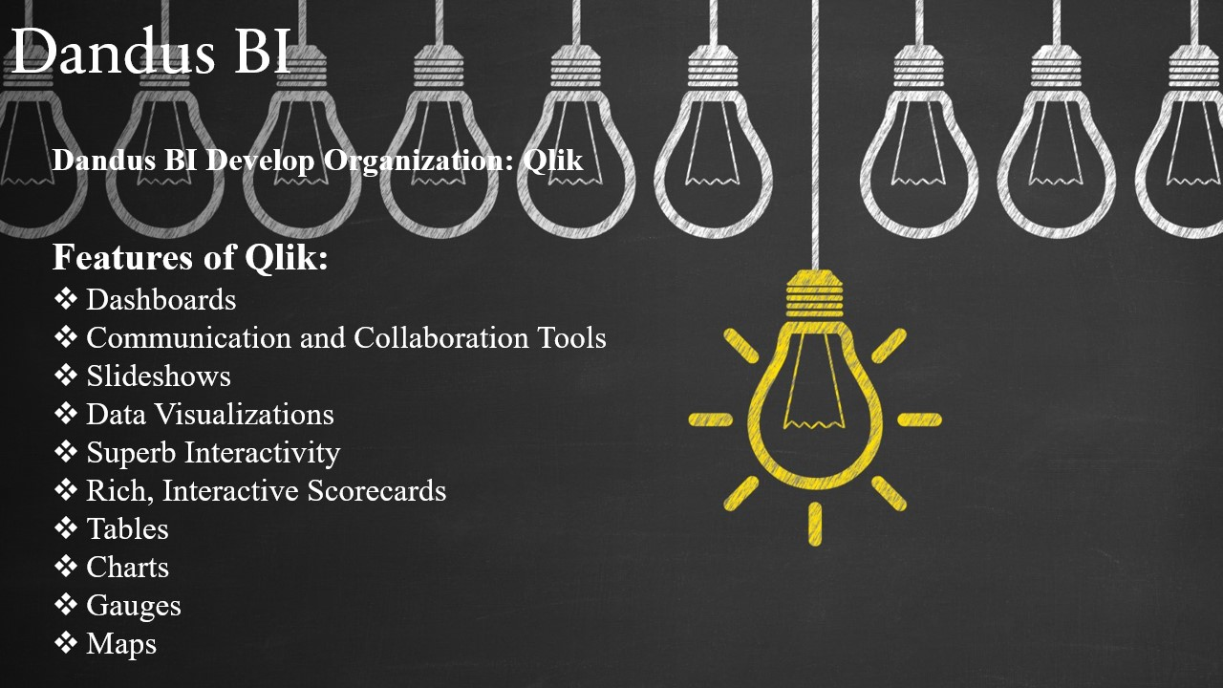

Figure 8 Slide_8

What is Dundas bi?

Dundas BI is a powerful browser-based analytics solution that enables users to generate interactive dashboards, customize their visualizations, build reports and drill down into data. It is flexible and scalable, with a responsive design that lets users integrate data from any kind of source in real time.

Dundas BI Develop Organization: Qlik

Features of Qlik:

* Dashboards
* Communication and Collaboration Tools
* Slideshows
* Data Visualizations
* Superb Interactivity
* Rich, Interactive Scorecards
* Tables
* Charts
* Gauges
* Maps

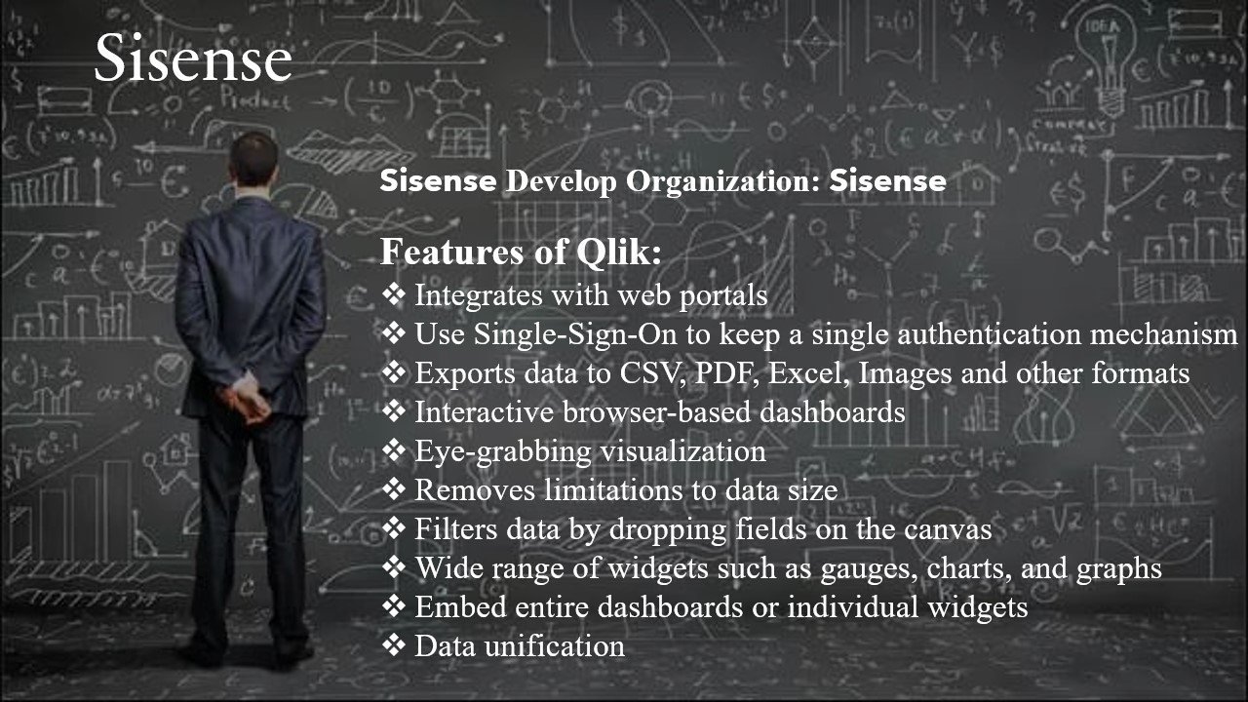

Figure 9 Slide_9

What is sisence?

The Sisense data & analytics platform makes it incredibly easy to mashup data across your entire data landscape and transform it into powerful, actionable analytics applications that can be embedded anywhere. From innovative startups to global brands like GE, Wix, Nasdaq, and Philips, thousands of organizations worldwide use Sisense to accelerate innovation and drive digital transformation by embedding Sisense into their businesses.

Sisense Develop Organization: Sisense

Features of Qlik:

* Integrates with web portals
* Use Single-Sign-On to keep a single authentication mechanism
* Exports data to CSV, PDF, Excel, Images and other formats
* Interactive browser-based dashboards
* Eye-grabbing visualization
* Removes limitations to data size
* Filters data by dropping fields on the canvas
* Wide range of widgets such as gauges, charts, and graphs
* Embed entire dashboards or individual widgets
* Data unification



Figure 10 Slide_10



Figure 11 Slide_11

# Task 2

## Task 2.1

# Compare the types of support available for business decision making varying levels within an organization

## Type of support available for business decision making

In today’s dynamic world business firms have to take a number of decisions every now and then. Managers know how important decision making is from the organizational point of view. For example, in research and development management has to decide whether to pursue one or multiple design strategies. Decision making capacity plays vital role in every type of business. So, we have to make correct decision in our every step of business. For that we can use different types of support system available for business decision making at different level that helps us to make correct decision. A decision support system is a computerized information system used to support decision-making in an organization or a business. A DSS lets users sift through and analyze massive amounts of data, and compile information that can be used to solve problems and make better decisions. Decision support systems allow for more informed decision-making, timely problem-solving, and improved efficiency for dealing with problems with rapidly changing variables. Following are some decision-making supports available:

1. Communication driven support

It is a type of support system that emphasizes communications, collaboration and shared decision-making support. It enables communication between groups of people, facilitates the sharing of information, supports collaboration and coordination between people and also supports in group decision tasks.

1. Knowledge driven support

Knowledge should be shared. It only grows by sharing”. Like it’s important to share knowledge within the organization, it’s equally important to determine what to share with whom. Not all details can be shared with everyone. This means that it is absolutely necessary to decide knowledge sharing rules and regulations, so that it can be used effectively and appropriately. It is a computer-based reasoning system that provides information, comprehension and suggest to users and support them in decision making.

1. Document driven support

A document driven support helps in document retrieval and analysis a collection of related, unstructured documents searches engines, document indexing and summarization document and knowledge management. The decision support systems is capable of gathering and presenting several typical information such as comparative data figures, accessing information assets that include relational and legacy data sources, consequences of diverse decision alternatives, providing past experiences in a particular context as well as projecting figures according to assumptions or new data.

1. Data driven support

It is a type of support that emphasizes access to and manipulation of a time-series of internal company data and sometimes external data. Simple file systems accessed by query and retrieval tools provide the most elementary level of functionality. Data warehouse systems that allow the manipulation of data by computerized tools tailored to a specific task and setting or by more general tools and operators provide additional functionality. Data-driven DSS with On-line Analytical Processing (OLAP) provides the highest level of functionality and decision support that is linked to analysis of large collections of historical data. Executive Information Systems (EIS) and Geographic Information Systems (GIS) are special purpose Data-Driven DSS.

In above I have discussed different types of support available in business decision making. Now I am going to discuss this support system in different varying level regarding our company.

## Decision making at different levels in the organization

Continuous analysis of organizational decision-making process is essential to high quality and transparent decisions; otherwise, a business runs with a prejudice: the notion that it is good at making decision, even if in reality it is not. Some decisions are related to evaluating investments, allocating resources or assessing mergers and acquisition proposals while some are about introducing new products, studying their shelf life or enhancing manufacturing efficiency. There are also day-to-day decisions that are valid for a point of time. Typically, more objective decisions are made at lower levels of hierarchy, which can be quantified. Higher levels of hierarchy deal with unstructured or ill-structured decisions, which are subjective in nature. While objective decisions may not require creativity, subjective decisions do.



Like decisions made in each department at each level are different, similarly a decision support system analyst must take into consideration the type of decisions and distinguished factors influencing decision-making before going to the drawing board and designing the architecture. Above fig gives an indication of the relative number of each type of decision made at each level in the organizations. However, the categories should not be treated as exclusive. For example, the production manager of a machinery manufacturing firm might primarily be engaged in technical decisions, while the legal adviser of the company might be involved in institutional matters.

From above, we have three different types of decision-making level. There are

1. Strategic level (top level management)
2. Tactical level (middle level management)
3. Operational level (bottom level management)

## Comparative study on different decision making at varying level

|  |  |  |
| --- | --- | --- |
| **Strategic level (top level management)** | **Tactical level (middle level management)** | **Operational level (bottom level management)** |
| It includes technology decisions (i.e. choice of appropriate technology, equipment’s, process choice and degree of automation), capacity decisions (amount, timing and type), facilitates decisions (size, location and specializations), vertical integration (direction, extent and balance). | It includes establishing parameters (for measuring operational efficiency and productivity), making plans to improve utilization of existing resources, planning for modernization, make or buy decision, planning for medium term maintenance (preventive and condition monitoring) to enhance the availability of production facilities. | It develops operational plans, establish actions that are necessary to achieve operational goals, Quality specifications and inspection and test details. |
| Creative skills are needed in Top level management. | Persuasive skills are needed in Middle level management. | Operative skills are needed in low level management. |
| Strategic level production planning helps to achieve the goals in the best possible way | Focus is on fixing performance parameters and generating data to compare actual and planned performance and taking steps to reduce gap between planned and actual. | Plans are definite, and action oriented and plans are expressed in terms of parameters, which can be quantified. |
| All the strategic level planning is always associated with risk and it is used in some futuristic assumption. | Plans to enhance equipment availability and overall productivity of the production function. | It helps to monitor the progress of the plan and take corrective action if needed to achieve the target. |
| This type of support is carried out for a long period of time. | This type of support is for certain period of time. | Operation are normally carried out for a short period of time. |
| This type of support coordinates the activities of different department. | This type of support cooperates with other department for smooth functioning of organization. | This type of support ensures whether good working condition is provided to the workers. |
| Only certain number of persons are needed to support. | Moderate number of persons are needed to provide support. | Support from large number of persons are needed. |

Table 1 Decision making at varying level

## Task 2.2

# Justify, with specific example, the key features of business intelligence functionality

Business intelligence is a technology driven process which analyze the data and present actionable information to help executives, managers and other end users to make effective business decisions. BI uses wide variety of tools, applications and methodologies that enable organization to collect data from various sources. Business Intelligence delivers the insight executives need in order to make the right decisions because it connects the data, technology, analytics, and knowledge that business professionals need to ensure success. It is with Business Intelligence that organizations and enterprises gain competitive advantage. Organizations around the globe are just now beginning to realize all of the potential benefits of Business Intelligence, as they harness the power of Big Data. Companies that use BI effectively also identify market trends and business issues that need to be corrected.

## Business intelligence functionality

Some of the key features of business intelligence functionality are as follows;

1. Predictive analytics and modeling

BI solution majorly helps you to analyze the data and trends by analyzing your previous data sets. But one capability which a BI solution must have is the predicting capabilities, it enables the decision makers to predict the market trends, and other business requirements like sales, staffing, market trends etc. With the use of predictive analytics, it helps an organization to be proactive, forward looking, retain and grow their customer with improving business operation on their business.



Figure 12 Predicative analytics

Predictive analytics is reflected in today Big Data Trends, and its tools are essentially Big Data Technologies. The market demand for predictive analytics software corresponds with a closely related toolset, Big Data Analytics Tools. It helps optimizing marketing campaigns, improving operations, fraud detection and reduce risks. For example, retail is Probably the largest sector to use predictive analytics, retail is always looking to improve its sales position and forge better relations with customers. One of the most ubiquitous examples is Amazon’s recommendations. When you make a purchase, it puts up a list of other similar items that other buyers purchased. Much of this is in the pre-sale area – with things like sales forecasting and market analysis, customer segmentation, revisions to business models, aligning IT to business units, managing inventory to account for seasonality, and finding best retail locations. But it also acts post-sale, acting to reduce returns, get the customer to come back and extend warranty sales.

1. Interactive Report and Operational Reports

Interactive reports allow users to condense the massive amounts of collected data into a wide variety of possible views. Users can take advantages of features like statistical analysis and regression to identify trends, anomalies and outliers in the data whereas At the end of each day, business intelligence features like these can provide your organization’s executives with a detailed summary of the daily events, giving them the information they need to make critical decision.

1. Data visualization

Data visualization is the process of interacting with clients to understand patterns, trends, and insights by transforming data into a visual context. Data visualization is to generate visuals from the data. It can be in any form like tables, graphs, charts, images, patterns, movies, etc.



Figure 13 Data visualization

In above figure we can see monthly expenses report that compares spending data across categories travel, office supplies, etc. or even across departments. While such trends could be easily overlooked in a spreadsheet, a bar chart will visualize the data. It’s an easy way to compare information, as it will uncover highs and lows at a quick glance. An accounting department can present the information to leadership or department heads and gain immediate understanding of challenges.

1. Open integration

Smart BI platforms will be able to access not only your organization’s own data, but information from email, social media, websites and more. For example, instead of only providing your internal sales data, your BI platform could accompany that information with reviews and comments about your products. With so many data formats and so many applications to pull from, it’s important that your BI platform is able to integrate as many different types of data as possible under a single roof, seamlessly combining disparate forms of information into an actionable report.

1. Ranking Reporting

This feature allows you to create reports that order specific categories of information, from across multiple dimensions, by selecting specific criteria. With the help of ranking report an organization get an idea of what aspect is going good and what aspect is going bad on their business. An organization can take critical decision by analyzing ranking report which helps them to change their state. Ranking reports let you view the best and worst performing aspects of your business. For example, you could create a report that ranks your 10 best-selling products, regions or sales people.

# Compare and contrast a range of information systems and technologies that can be used to support organization at operational tactical and strategies levels

For the last twenty years, different kinds of information systems are developed for different purposes, depending on the need of the business. In today’s business world, there are varieties of information systems such as transaction processing systems (TPS), office automation systems (OAS), management information systems (MIS), decision support system (DSS), and executive information systems (EIS), Expert System (ES) etc. Each plays a different role in organizational hierarchy and management operations. This study attempts to explain the role of each type of information systems in business organizations.

## Four major types of systems



Figure 14 Four major types of systems

Above figure shows the specific types of information systems that correspond to each organizational level. The organization has executive support systems (ESS) at the strategic level; management information systems (MIS) and decision-support systems (DSS) at the management level; and transaction processing systems (TPS) at the operational level. Systems at each level in turn are specialized to serve each of the major functional areas. Thus, the typical systems found in organizations are designed to assist workers or managers at each level and in the functions of sales and marketing, manufacturing and production, finance and accounting, and human resources. The four major information support systems are discussed below:

## Executive support system (ESS)

Executive information systems have been developed, which provide rapid access to both internal and external information, often presented in graphical format, but with the ability to present more detailed underlying data if it is required.



Figure 15 ESS

Senior managers use executive support systems (ESS) to help them make decisions. ESS serve the strategic level of the organization. They address nonroutine decisions requiring judgment, evaluation, and insight because there is no agreed-on procedure for arriving at a solution. Executive information systems provide critical information from a wide variety of internal and external sources (from MIS, DSS, and other sources tailored to the information needs of executives) in easy-to use displays to executives and managers. An EIS provides senior managers with a system to assist in taking strategic and tactical decisions. An executive information system is designed to generate information that is abstract enough to present the whole company operation in a simplified version to satisfy senior management

## Management information system (MIS)

Management information systems are a kind of computer information systems that could collect and process information from different sources in institute decision making in level of management. Management information systems Provide information in the form of prespecified reports and displays to support business decision making. The next level in the organizational hierarchy is occupied by low level managers and supervisors. This level contains computer systems that are intended to assist operational management in monitoring and controlling the transaction processing activities that occur at clerical level. Management information systems (MIS) use the data collected by the TPS to provide supervisors with the necessary control reports. Management information system is type of information systems that take internal data from the system and summarized it to meaningful and useful forms as management reports to use it to support management activities and decision making.



Figure 16 MIS

Above figure shows how a typical MIS transforms transaction level data from inventory, production, and accounting into MIS files that are used to provide managers with reports.

## Decision support system (DSS)

A Decision Support System is a computer-based system intended for use by a particular manager or usually a group of managers at any organizational level in making a decision in the process of solving a semi structured decision. Decision Support Systems are a Kind of organizational information computerize systems that help manager in decision making that needs modeling, formulation, calculating, comparing, selecting the best option or predict the scenarios. Decision support systems are specifically designed to help management make decisions in situations where there is uncertainty about the possible outcomes of those decisions. A decision support system is a computer-based information system that assists managers in making many complex decisions, such as decisions needed to solve poorly defined or semi structured problems.



Figure 17 DIS

Above figure illustrates the DSS built for this company. The system operates on a powerful desktop personal computer, providing a system of menus that makes it easy for users to enter data or obtain information.

## Transaction support system (TPS)

Transaction processing systems (TPS) are the basic business systems that serve the operational level of the organization. A transaction processing system is a computerized system that performs and records the daily routine transactions necessary to the conduct of the business. At the lowest level of the organizational hierarchy, we find the transaction processing systems that support the day today activities of the business.



Figure 18 TPS

Above figure depicts a payroll TPS, which I s a typical accounting transaction processing system found in most firms. A payroll system keeps track of the money paid to employees. The master file is composed of discrete pieces of information (such as a name, address, or employee number) called data elements. Data are keyed into the system, updating the data elements. The elements on the master file are combined in different ways to make up reports of interest to management and government agencies and to send paychecks to employees. These TPS can generate other report combinations of existing data elements.

## Relationship to system to one another



Figure 19 Relationship to system

Above figure describe how the systems serving different levels in the organization are related to one another. TPS are typically a major source of data for other systems, whereas ESS are primarily a recipient of data from lower-level systems. The other types of systems may exchange data with each other as well. Data may also be exchanged among systems serving different functional areas. For example, an order captured by a sales system may be transmitted to a manufacturing system as a transaction for producing or delivering the product specified in the order or to a MIS for financial reporting.

# Task 3

## Task 3.1

# Presentation & Speaker Notes

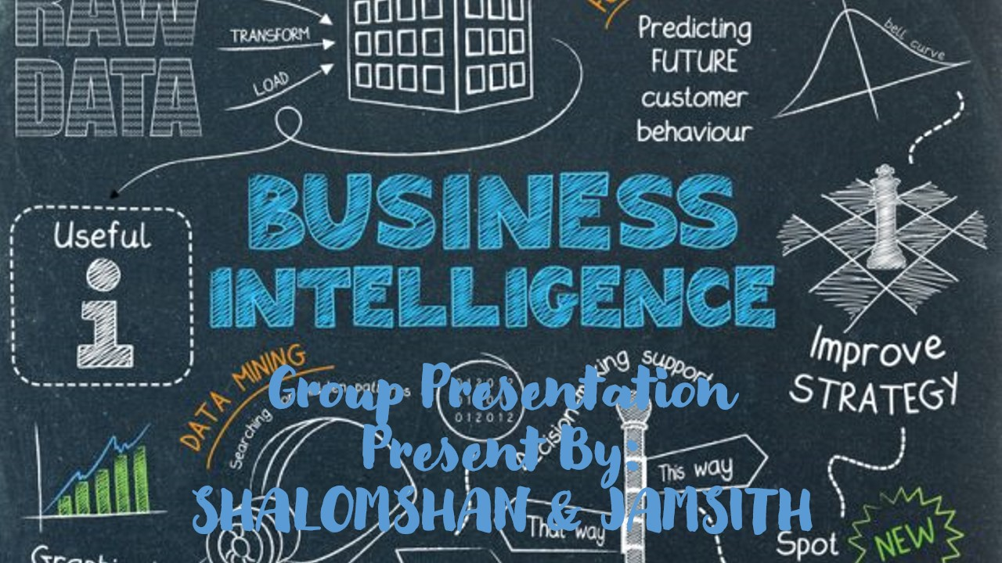

Figure 20 Slide_1

Hi everyone welcome back our another presentation this our group presentation my group member is jamsith. So today we are going to present BI

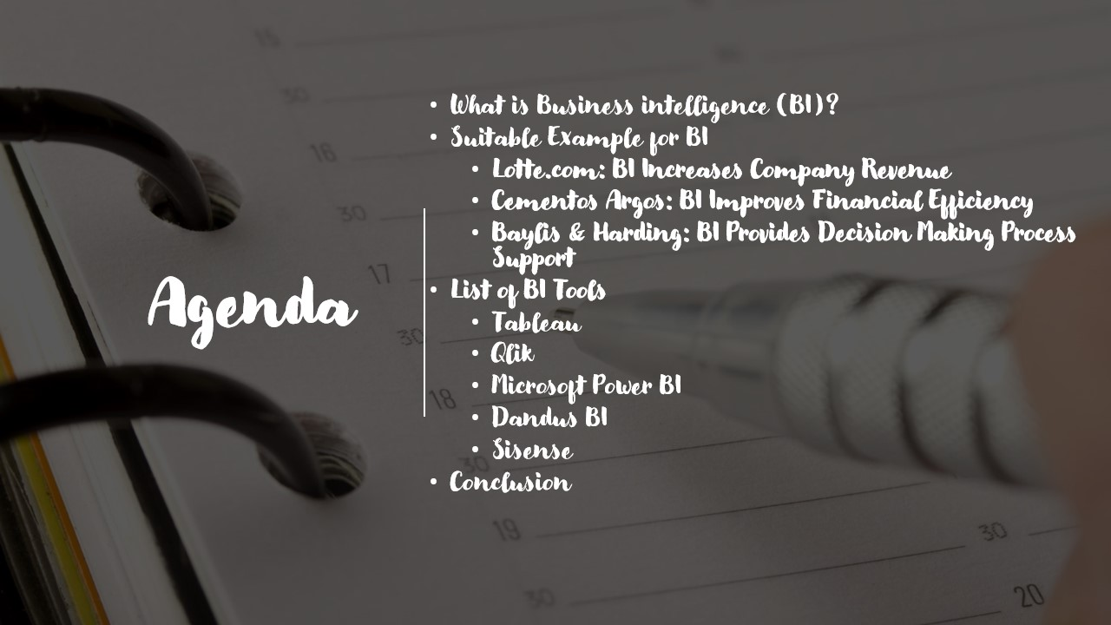

Figure 21 Slide_2

So this our content page these are content our presentation.

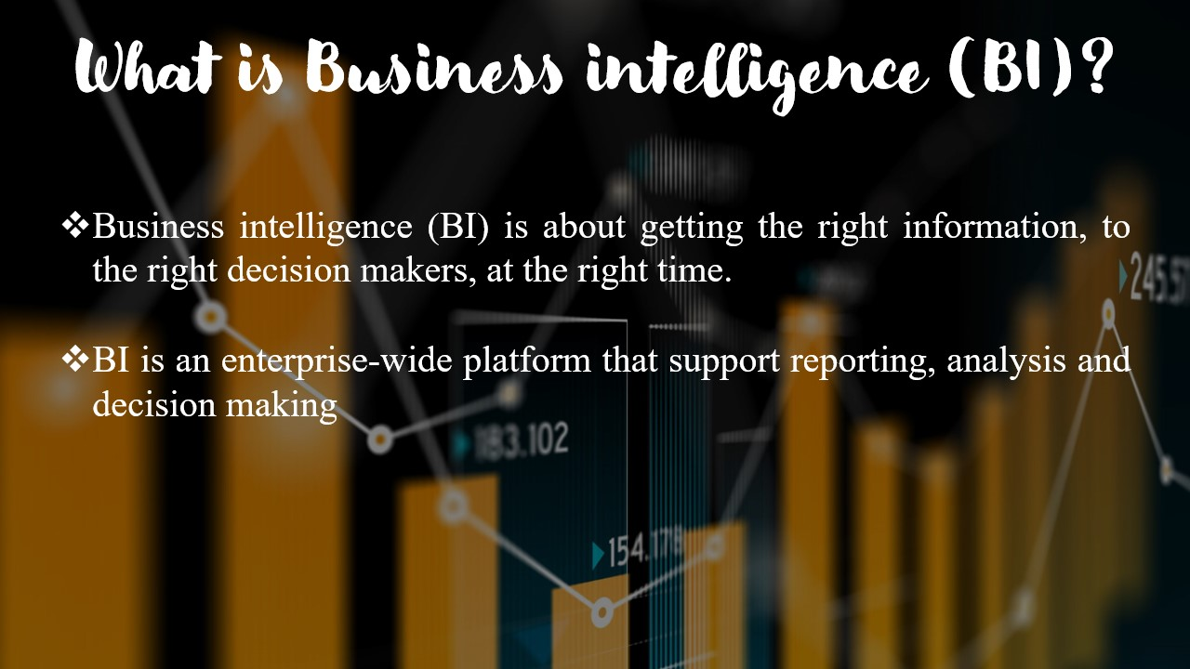

Figure 22 Slide_3

What is business intelligence (BI)?

* Business intelligence (BI) is about getting the right information, to the right decision makers, at the right time.
* BI is an enterprise-wide platform that support reporting, analysis and decision making

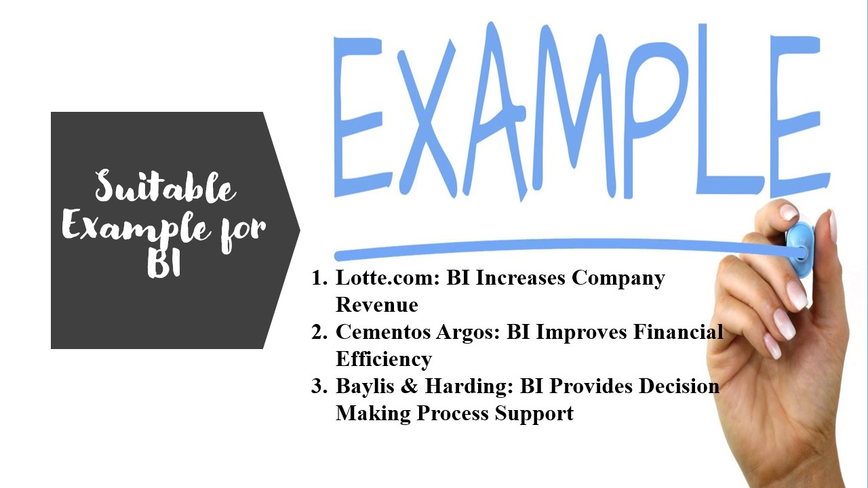

Figure 23 Slide_4

Suitable example for BI

1. Lotte.com: BI Increases Company Revenue
2. Cementos Argos: BI Improves Financial Efficiency
3. Baylis & Harding: BI Provides Decision Making Process Support

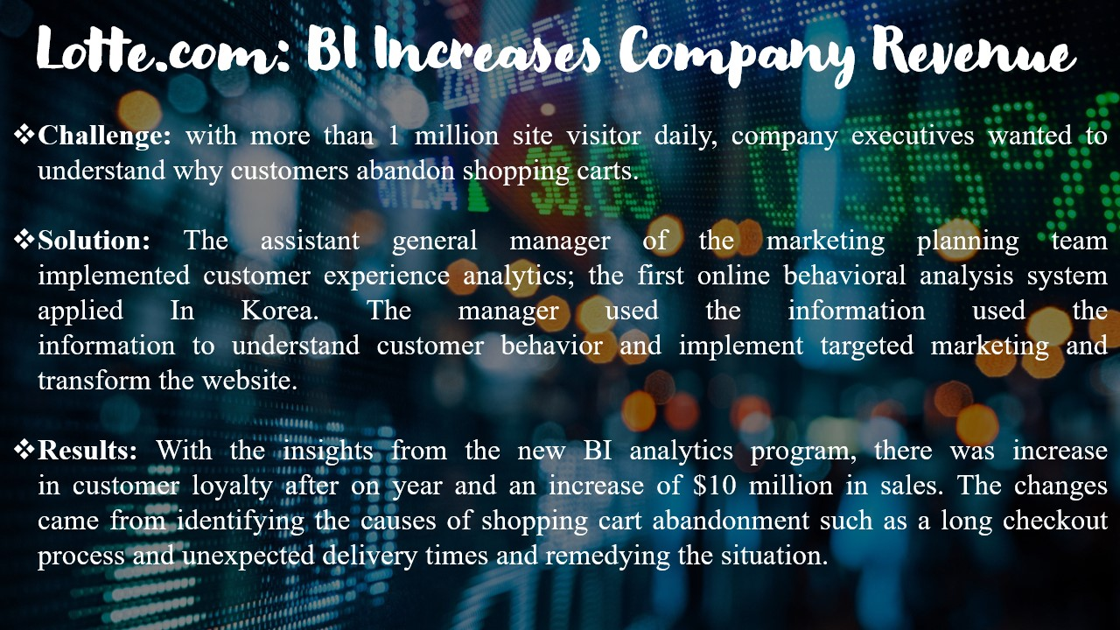

Figure 24 Slide_5

Lotte.com: BI Increases Company Revenue

* **Challenge:** with more than 1 million site visitor daily, company executives wanted to understand why customers abandon shopping carts.
* **Solution:** The assistant general manager of the marketing planning team implemented customer experience analytics; the first online behavioral analysis system applied In Korea. The manager used the information used the information to understand customer behavior and implement targeted marketing and transform the website.
* **Results:** With the insights from the new BI analytics program, there was increase in customer loyalty after on year and an increase of $10 million in sales. The changes came from identifying the causes of shopping cart abandonment such as a long checkout process and unexpected delivery times and remedying the situation.

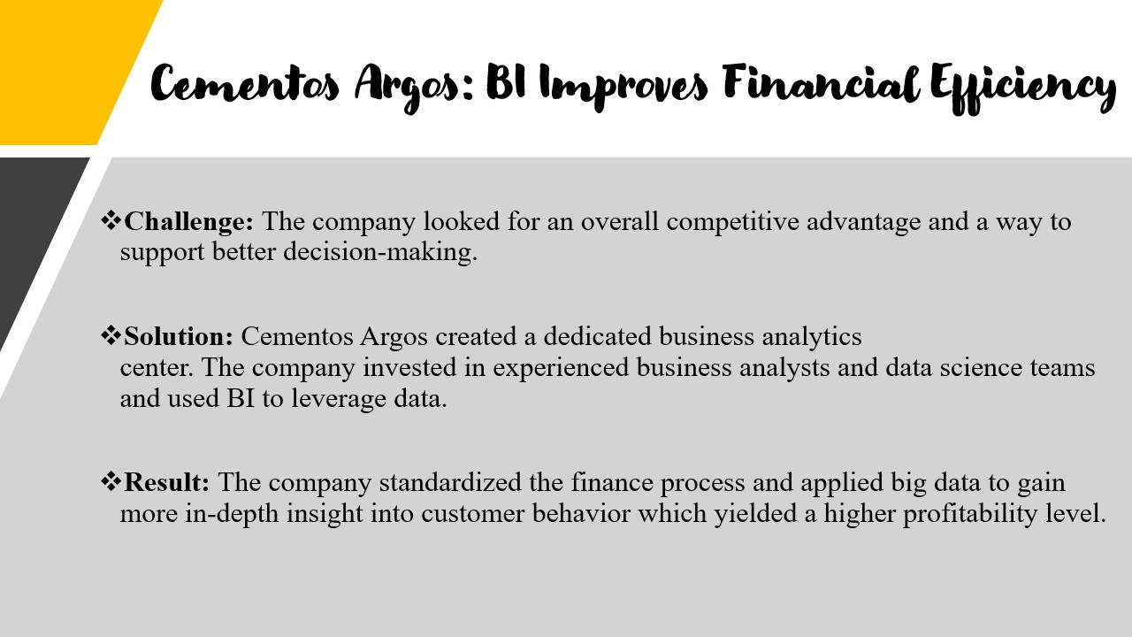

Figure 25 Slide_6

Cementos Argos: BI Improves Financial Efficiency

* **Challenge:** The company looked for an overall competitive advantage and a way to support better decision-making.
* **Solution:** Cementos Argos created a dedicated business analytics center. The company invested in experienced business analysts and data science teams and used BI to leverage data.
* **Result:** The company standardized the finance process and applied big data to gain more in-depth insight into customer behavior which yielded a higher profitability level.

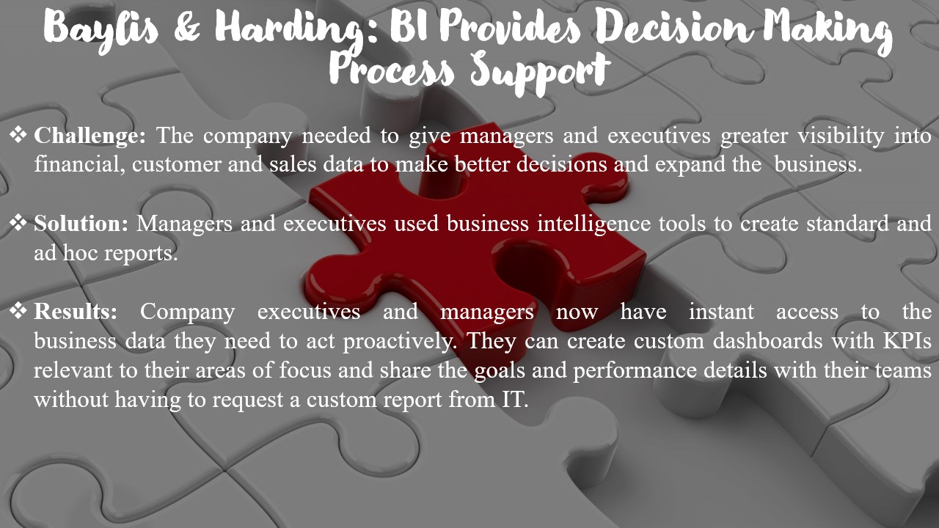

Figure 26 Slide_7

Baylis & Harding: BI Provides Decision Making Process Support

* **Challenge:** The company needed to give managers and executives greater visibility into financial, customer and sales data to make better decisions and expand the  business.
* **Solution:** Managers and executives used business intelligence tools to create standard and ad hoc reports.
* **Results:** Company executives and managers now have instant access to the business data they need to act proactively. They can create custom dashboards with KPIs relevant to their areas of focus and share the goals and performance details with their teams without having to request a custom report from IT.

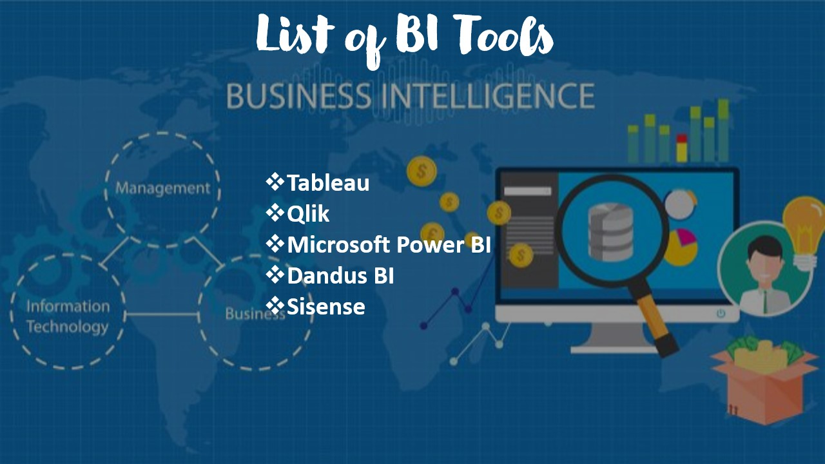

Figure 27 Slide_8

List of BI tools

Tableau, qlik, Microsoft power BI, dandus BI, sisense and these bi tools I will explained deeply.

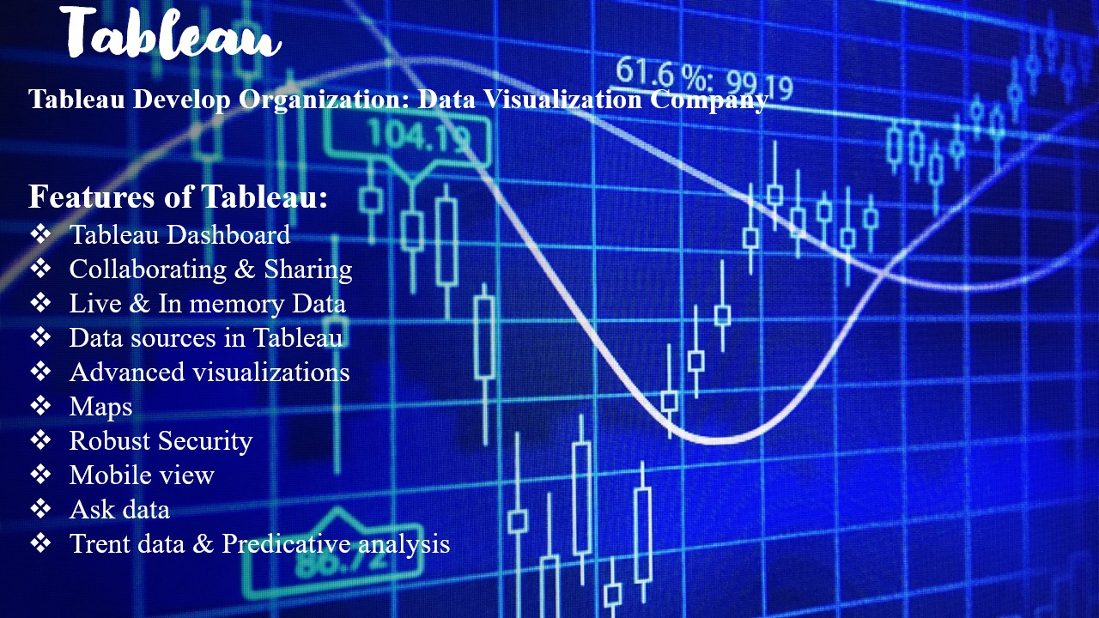

Figure 28 Slide_9

**What is tableau?** is a powerful and fastest growing data visualization tool used in the Business Intelligence Industry. It helps in simplifying raw data in a very easily understandable format. Tableau helps create the data that can be understood by professionals at any level in an organization. It also allows non-technical users to create customized dashboards

Tableau Develop Organization: Data Visualization Company

Features of Tableau:

* Tableau Dashboard
* Collaborating & Sharing
* Live & In memory Data
* Data sources in Tableau
* Advanced visualizations
* Maps
* Robust Security
* Mobile view
* Ask data
* Trent data & Predicative analysis

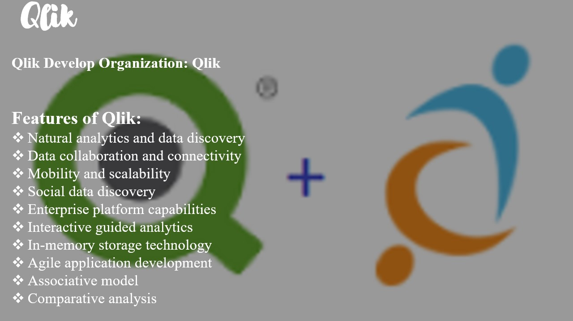

Figure 29 Slide_10

What is qlik?

**QlikView** is a business intelligence tool for data integration, conversational analytics, and converting raw data into a knowledge base. QlikView offers features for [ad hoc queries](https://www.guru99.com/all-about-ad-hoc-query.html) and facilitates quick decision-making based on easily accessible information.

Qlik Develop Organization: Qlik

Features of Qlik:

* Natural analytics and data discovery
* Data collaboration and connectivity
* Mobility and scalability
* Social data discovery
* Enterprise platform capabilities
* Interactive guided analytics
* In-memory storage technology
* Agile application development
* Associative model
* Comparative analysis

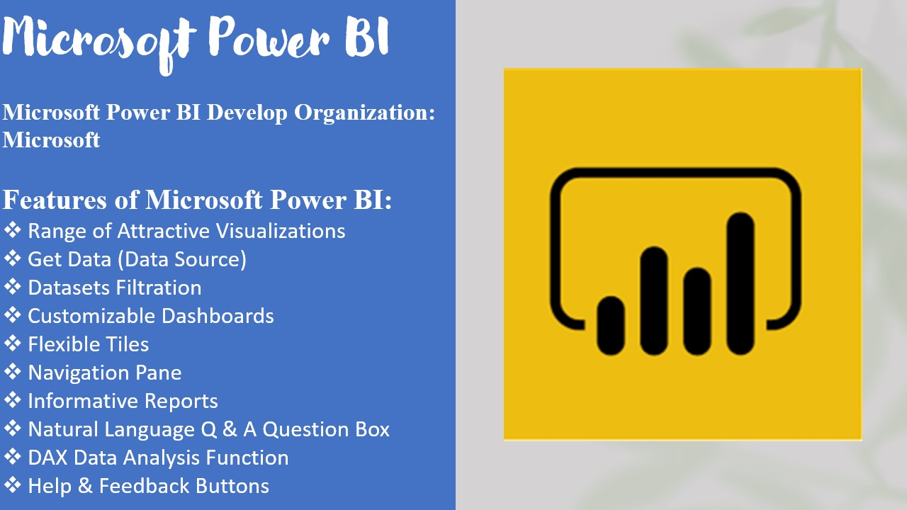

Figure 30 Slide_11

What is power bi?

Business intelligence is a technology-driven method which helps you to analyze data and to provide actionable information which helps corporate executives, business managers, and other users to make informed business decisions.

Microsoft Power BI Develop Organization: Microsoft

Features of Microsoft Power BI:

* Range of Attractive Visualizations
* Get Data (Data Source)
* Datasets Filtration
* Customizable Dashboards
* Flexible Tiles
* Navigation Pane
* Informative Reports
* Natural Language Q & A Question Box
* DAX Data Analysis Function
* Help & Feedback Buttons

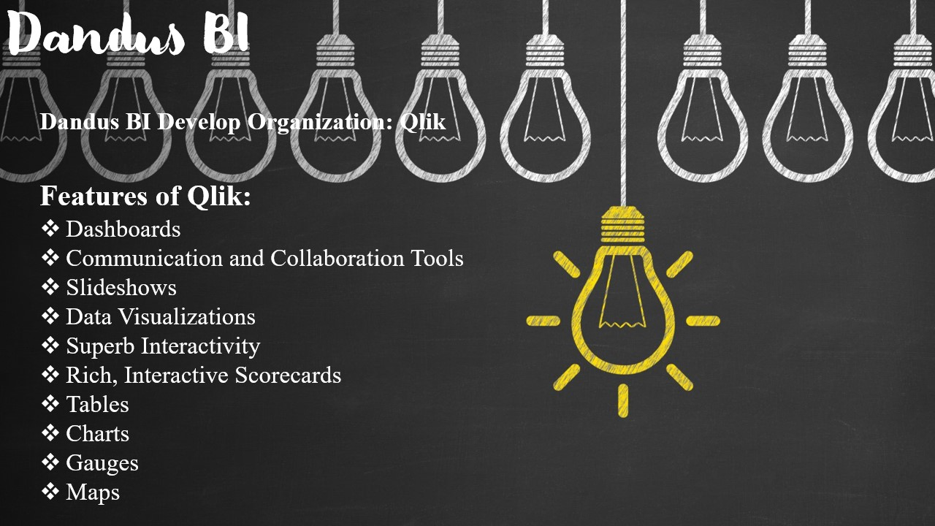

Figure 31 Slide_12

What is Dundas bi?

Dundas BI is a powerful browser-based analytics solution that enables users to generate interactive dashboards, customize their visualizations, build reports and drill down into data. It is flexible and scalable, with a responsive design that lets users integrate data from any kind of source in real time.

Dundas BI Develop Organization: Qlik

Features of Qlik:

* Dashboards
* Communication and Collaboration Tools
* Slideshows
* Data Visualizations
* Superb Interactivity
* Rich, Interactive Scorecards
* Tables
* Charts
* Gauges
* Maps

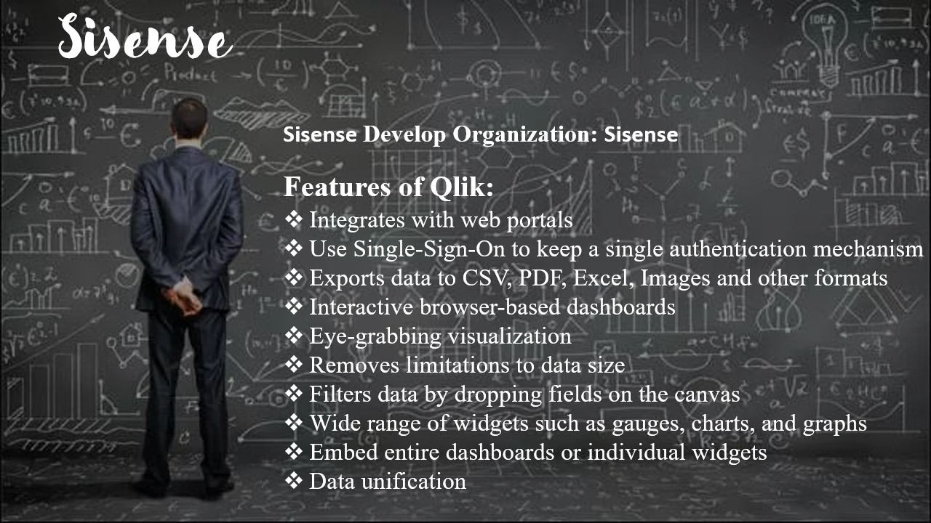

Figure 32 Slide_13

What is sisence?

The Sisense data & analytics platform makes it incredibly easy to mashup data across your entire data landscape and transform it into powerful, actionable analytics applications that can be embedded anywhere. From innovative startups to global brands like GE, Wix, Nasdaq, and Philips, thousands of organizations worldwide use Sisense to accelerate innovation and drive digital transformation by embedding Sisense into their businesses.

Sisense Develop Organization: Sisense

Features of Qlik:

* Integrates with web portals
* Use Single-Sign-On to keep a single authentication mechanism
* Exports data to CSV, PDF, Excel, Images and other formats
* Interactive browser-based dashboards
* Eye-grabbing visualization
* Removes limitations to data size
* Filters data by dropping fields on the canvas
* Wide range of widgets such as gauges, charts, and graphs
* Embed entire dashboards or individual widgets
* Data unification



Figure 33 Slide_14



Figure 34 Slide_15

## Task 3.2

# Design a BI tool, Application or interface for NOLIMIT to support their problem solving or decision making for their business requirements.

## Sales & Marketing Dashboards

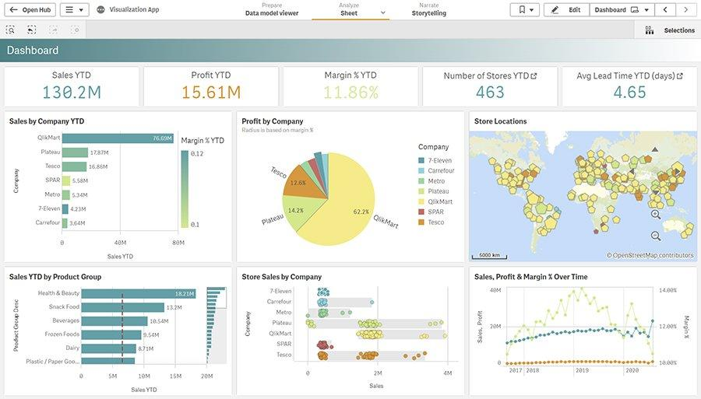

Figure 35 Sales dashboards like this one show data on product and retail sales, plus other sales-related metrics

These dashboards are widely used corporate executives, business managers and sales and marketing teams. A sales dashboard includes data on product or retail sales, the cost of sales operation and other enabling user to track progress against sales goals and identify potential trouble spots. Similarly, a marketing dashboard contains data on costs, response rates, lead generation and marketing metrics.

## Customer Dashboards



Figure 36 A customer dashboard displays data about a company's customers, as seen here in an interactive format.

A customer dashboard lets users view and analyze data about an organization customer base, including its size, churn and retention rates, revenue per customer, lifetime value and other customer metrics that can be used to help plan marketing campaigns and sales efforts.

## Financial Dashboards

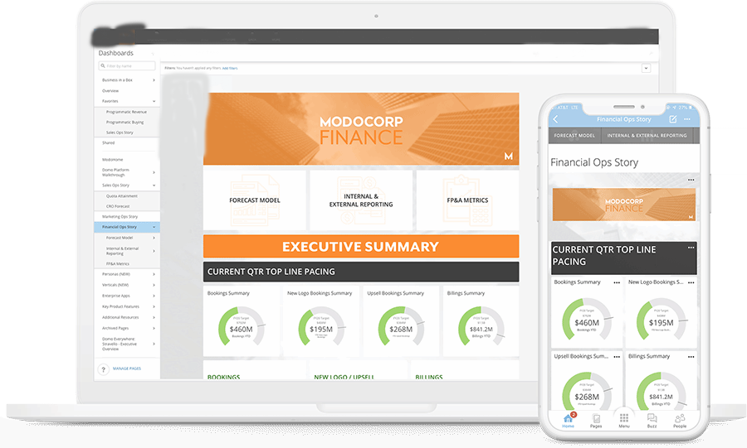

Figure 37 Financial dashboards include various finance-related metrics -- in both desktop and mobile views in this example

This type of dashboards displays data on financial other executives and workers in the finance department. The metrics in a financial dashboard range from revenue, operating expenses and profits to cash holdings, assets and liabilities, working capital, profit margins and more to help an organization monitor business performance and do financial planning and analysis.

## HR Dashboards

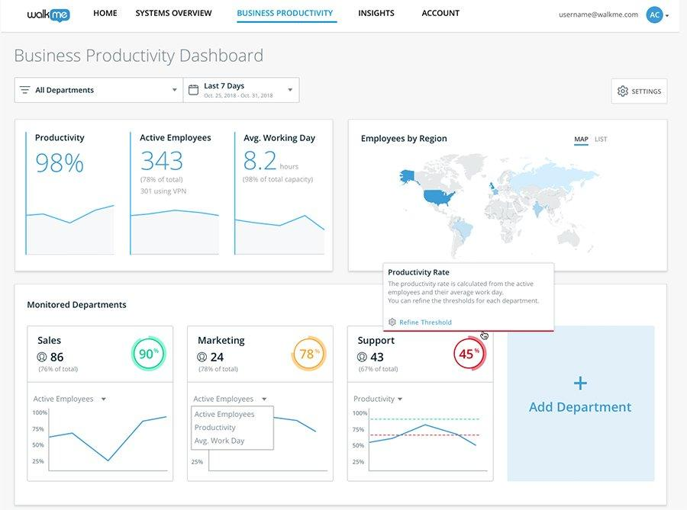

Figure 38 HR dashboards offer a mix of workforce and employee experience data; this one shows productivity metrics

An HR dashboard provides information on an organization workforce for use by HR managers and business executives. That includes basic workforce data, such as the number of employees, salary statistics and demographic, as well hiring and recruiting metrics and on things like employee satisfaction, turnover and costs to aid in talent management and employee experience initiatives.

## Operational Dashboards

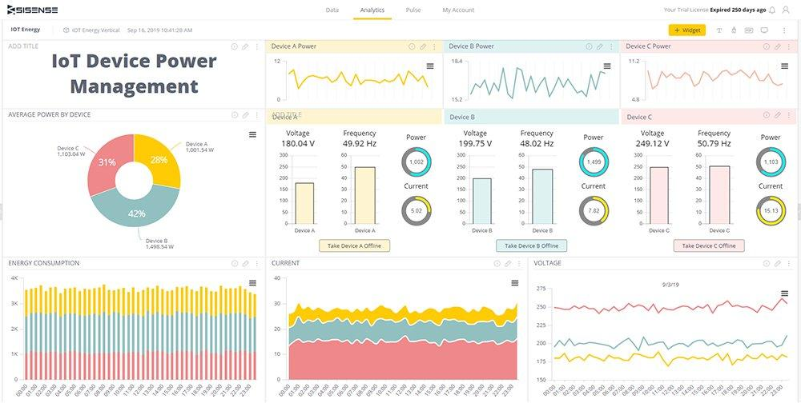

Figure 39 Operational dashboards contain data on business operations and processes, such as power usage by IoT devices

These dashboards track the status of operation, business processes and equipment on an ongoing basic for day-to-day monitoring and management uses. For example, an operational dashboard might show metrics on the output of manufacturing machines to help plant managers ensure that production goals are met and identify potential problems or bottlenecks that they need to address.

## IT Dashboards

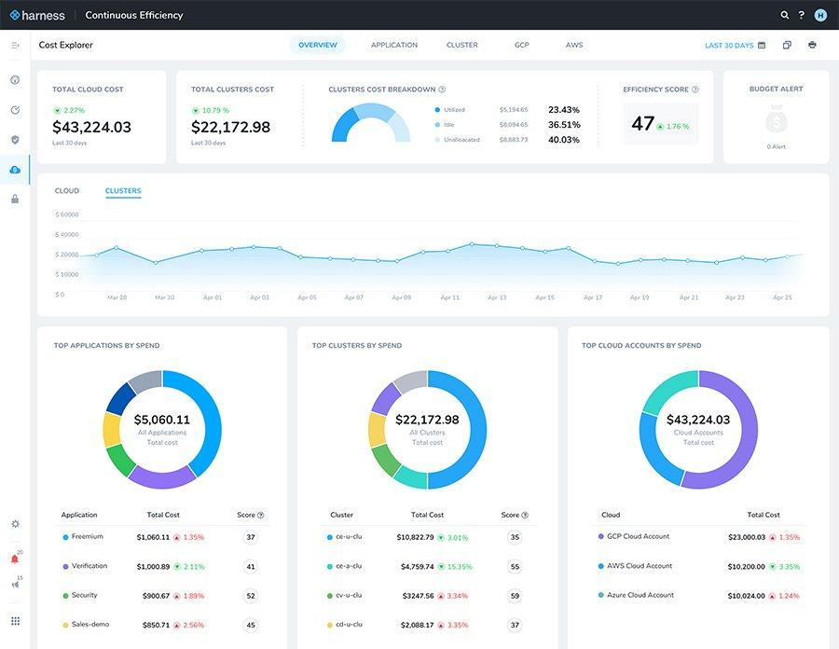

Figure 40 IT dashboards show data on technology usage and other IT metrics -- cloud computing costs in this case

IT departments and BI, data management, data warehousing and data science teams are big users of dashboards themselves. IT dashboards help them track metrics on various aspects of IT operations, including the use of networks, systems, databases and applications available IT resources performance problems security issues and technology cost.

## Project Dashboards

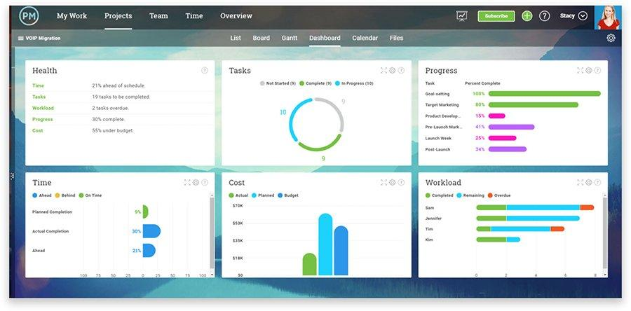

Figure 41 A project dashboard provides real-time metrics on projects so project managers can track their status

A project or project management dashboards displays data on the status and progress of business projects. Project managers can use one to track tasks deadlines, cost and other parameters to aid in monitoring work, spotting problems and keeping projects on schedule and budget.

## Mobile Dashboards

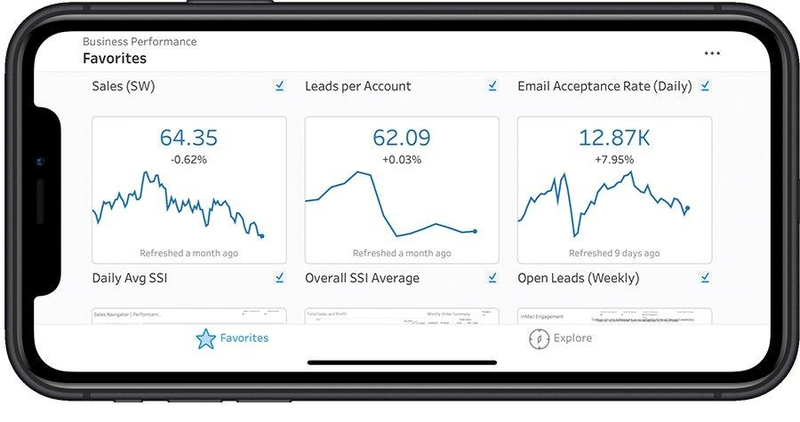

Figure 42 Mobile dashboards display data in a format suitable for mobile devices, such as this one showing sales

This isn’t an entirely separate dashboard category many BI dashboards are designed for both PCs and mobile devices. But dashboards designers looking to support mobile BI user need to ensure that dashboards display in a readable way on smartphones and tablets. As a result, mobile dashboards are often relatively simple, with a few data visualization that can be easily viewed on a small screen.

### Task 4

# Discuss how power bi business intelligence tools can contribute to effective decision making

Business Intelligence can be defined as a technologies and strategies used for collection and analysis of raw data, then converting it to meaningful information for business action. The main purpose of business intelligence is to support better decision making in business. Business intelligence can provide a company with rich data resource that can help it achieve its business goals and targets by guiding timely strategic decision. Interactions with customers through phone calls, email, online chat, etc. can be thoroughly analyzed by business intelligence gathering teams with the aim of getting vital insights that can be efficiently leveraged to provide immense value of the business in the long term.

Being in business ultimately means being in the business of decision making. Decision play vital role in any kind of business, right decision made at right time and implemented in the right manner make all differences. This surely has become difficult. Things change very quickly, we are far more connected, and we need to act fast while grappling with far more complexity. There always seem to be too many things to keep tab on, and too few ways to make sense of it all. Studies show that the highest performing businesses leverage data effectively for decision making.

Let’s talk on the basic of particular scenario, as for the marketing department, it helps them grow the top line. It helps them analyze the result of their campaign and promotional yields. And it helps them fine time their spending to get better ROI. In the sales department, business intelligence helps them find the best path and best practices, the cost and length of customer acquisition, process improvement, and year by year analysis of turnover and sales. Business intelligence helps the human resource department track and manage things like employee turnover, attrition rate, recruitment process, and so on. Aside these, everyday other department within a company will benefit directly or indirectly from business intelligence. Correct usage of this strategy has shown excellent result across all sector be it ecommerce, media, non-profit organization, healthcare telecommunication, financial service, energy, and so on.

Business intelligence help in decision making due to the multiple powerful elements it entails. These include interactivity, data visualization, database connection, mobile business intelligence, predictive analytics, application integration, and ad hoc reporting. Now let’s take a closer look at each of these elements.

# Decision making tools use in business intelligence

Some of the effective decision that Business Intelligence tools helps to make are

1. **Interactivity**

There should be a heigh level of interactivity between the dashboard and the difference report. For example, if a person is seeing and analyzing the total sales report, some interaction should be involved. This will help the person big further into the report to figure out region wise sales, product wise sales, time period wise sales and so on. The more the level of interaction, the more the volume of vital information that will be retrieved and the better the decision that will be made.

1. **Data visualization**

Having data visualized in a correct format is very important as this facilitates better understanding of the data. For example, month on month sales could be represented in the form of the line graph rather then just words or verbal communication. Similarly, a component wise contribution could be best represented with a pie chart. Only when data is represented in the correct format can any useful insight be extracted from it.

1. **Connection to databases**

During a business intelligence procedure, the analysts in charge should be able to fetch information by connecting to different database and web services, so that they will get access to the right information irrespective of its source. With the right information, helpful recommendations can be made that help a company grow.

1. **Predictive analytics**

With the aid historical data end algorithms, certain predictions can be made, such as the likelihood of customer coming back for repeat business, expected revenue, expected region wise sales, machine failure, and so on. This can help a company to be proactive.

1. **Application integration**

A business intelligence tool should be easily integrated with your existing application or software regardless of whether it is developed in Java, C, Ruby, PHP, or any other platform.

1. **Mobile business intelligence**

With more and more workforce going mobile and handling task on the move, they need to have the right information on their mobile devices, such as smartphones and tablets. So, all reports dashboards and graphs should be compatible with mobile devices.

This is not limited to just a few roles in the organization. At all levels people need to make decisions be accountable and confident. And if organizations can enable its employees with right tools chances are that they will get it right. Informed decision making relies on current and comprehensive information. Relevant information often resides in a multitude of source a plethora of databases, documents, spreadsheets, social networks, or web access to data models which bring together these sources in meaningful manner allow decision maker to be equipped with timely information and be not blindsides.

There can be too much information though. Only through right visualization and summarization we can understand and analyze it well generating insight as we draw conclusion. This happens when we are able to visualize information as relevant to the business model. Insightful tools can identify pattern, allow us analyze scenarios, and plan better. These insights influence decisions in a powerful manner.

Hence, powerful decision making is about being able to confident and accountable. Decisiveness that works comes from being informed, insightful and impactful. The confidence that arises from comprehensive information, deep understanding and ability to implement, leads to results.

# Explore the legal issues involved in the secure exploitation of business intelligence tools

The business intelligence tools that are used for the effective decision making for a business can have some legal issues as well. As everything is digital, the used are also some sort of software. So, the software that are used should be used the authorized person so that one can make the use of the analyzed data. As these thigs are critical and are supposed to be kept safe. The privacy and security are also a legal issue. The privacy of the data should be maintained and the security should be great enough to protect the data. For these various tools and techniques are available. The tools are supposed to be used correctly and for the benefit of the business and not for personal use.

## Cyber security management

Cybersecurity management can be described as everything an organization does to protect its information systems and computer network from cyber-attacks, instruction, malware and various types of data breaches. All business and government agencies are vulnerable to cyber-attacks that are growing in sophistication, as well as in number. Keeping networks running smoothly and protecting sensitive data takes constant monitoring and proper cybersecurity management. Business intelligence strategy has ushered in a new era for organization the work over. A strong focus on data analysis has business leaders enjoying reduced costs, increased efficiency, and all-around better decision making. When previously unheard-of ROI is touted in headlines regularly it sparks more businesses to follow suit and jump on the BI movement. However, many do so without considering and full implications of business intelligence on data security.

Basically, the BI tools are used for the organizational, personal and legal / regulatory context to store the valuable data. For the organization like out IT company, we use the BI tools store the data that we have obtain from the research and analyze the data that we have stored. By doing this we can give competition to the many organizations like ours. In one line it can be said that in most of the context BI tools are used to store and to protect the data.

## Discovering BI security risk

The mere act of producing or housing data always poses a danger if lift unsecured. Those incorporating BI strategy into their operation are at least more aware of their data of what it is and where it is housed. But knowledge doesn’t equate to secure. The insights drawn from BI and data analysis are no longer unstructured 1s and 0s, but highly sensitive easily understandable information marketing it even more valuable to a hacker. If they can steal data that has already been analyzed then they are in effect stealing the very keys to your success. Liken it to a car thief. Instead of just robbing a garage for few spare parts they’re boosting Ferraris right of the dealing ship lot.

# Methods to protect the risk

In every context their different kinds of risk related to the BI and BI tools. The best methods to protect those risk for the organizational personal and legal / regulatory context are as

## Encrypting & Segmenting data insights

Given that BI insights are of extreme value to hackers, it’s especially important to secure data once it’s unraveled. Many base level essential security practices must be adapted to business intelligence. Before insights are stored or send to someone else, they must be encrypted. At the very least time practice will drastically slow down a hacker from making sense of our private data. Today it’s possible to encrypt massive amounts of information quickly proven by the IBM z machine which can process 12 billion encrypted transactions per day. Neglecting encryption is a mistake and more that may have contributed to the enormous Equifax breach additionality thinking strategically about segment both out network and data storage. Siloed raw data is inefficient for analysis but siloed data insights can be a safe practice. This way should a hacker gain access to one section of our network they won’t have automatic access to every insight we have. It’s the difference between mining for gold nuggets and strolling into a vault at fort Knox.

## Determining access and permissions

BI insights are powerful and power in the hands of the wrong user can be dangerous. While we may trust all our employees it’s not safe to give them all unlimited access to these insights. While employees should certainly see data results and trends that are applicable to their jobs, many of these items can be distributed to them from a supervisor or management. At the inception of a BI strategy, it’s necessary to scrutinize every employee’s role to determine the necessity of their access to bi tools and data. Even if we’re certain a disgruntled worker won’t try to wreak havoc and corrupt our data if they don’t truly need access to certain BI tools then they may neglect basic security measures (like updating their password) and serve as an unknowing invitation to a hacker

## Applying BI to data security

Many business leaders understand that data can be used to learn significant insights about their companies but the fact BI can be used to address security is often neglected. Data analysis can discover backdoors network inconsistencies or technological issues that hackers can take advantage of. With real time result BI security strategy can monitor data as it enters or leaves your organization to discover and questionable activities immediately.

# Conclusion

Business intelligence doesn’t have to be scary there are a variety of resources to educate and empower buyers. There are plenty of types of different BI tools out there to explore and experiment with. The more educated the user base becomes, the more comprehensive and powerful the options will become.

BI is a versatile and powerful resource, and can be useful to almost every industry. In this report I have discussed and determined, what business intelligence is and the tools and techniques associated with it including the examples, as well as I had designed a business intelligence tool, application or interface that can perform a specific task to support problem solving or decision-making at an advanced level also I had customized the design to ensure that it is user-friendly and has a functional interface and finally I had provided a critical review of the design in terms of how it meets a specific user or business requirement and identified what customization has been integrated into the design. Also, I have described and illustrate how a specific business intelligence tools going to help each and every aspect of an organization in order to make a better business decision making.

Then, I have explored what are the legal issues involved with the proper use of business intelligence tools for an organization such as the sector it is going to help and the benefits, they can get from each sector such as increase in productivity, Data privacy and security, for statistical analysis, etc. Here, I have conducted a research program to identify whether a particular organization uses or not a business intelligence tools in order to analyze, visualize and report their organizational data for the better productivity and enhancement of their product. Apart from that if they do not use then how they are able to manage their business of an organization and any types of methods they use.

And lastly, I have done evaluation on how these business intelligence tools going to help a specific organization to target their audience and for that what they should do. Apart from that how a specific organization can make their product better so that they can make more competition within the market and for the better development of their organization, taking security legislation into consideration.

# Reference